OUT OF THIS WORLD
a writing retreat led by Kenneth Steven
17th – 22nd March 2025 - Argyll Hotel, Isle of Iona
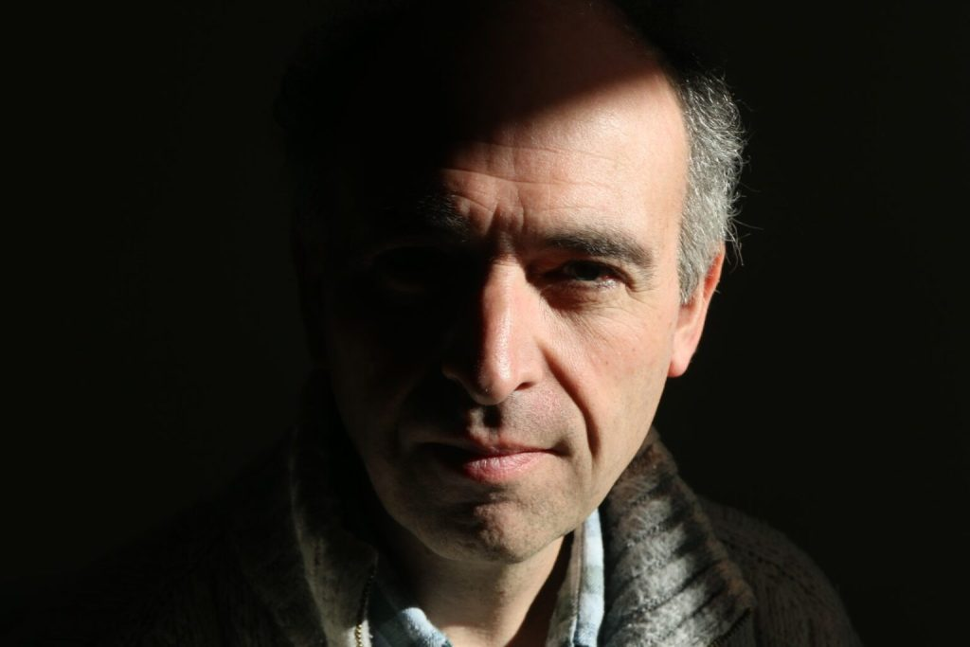
A chance to retreat from a crazily busy world and find inspiration in the sanctuary of the Isle of Iona. The Argyll Hotel is the perfect place for such a retreat in early spring: welcoming fires, cosy rooms and the most magnificent light. Outside is the island: its wild hills and secret coves.
Writer Kenneth Steven will give talks on how better to find inspiration and hone words. Kenneth has experience across the writing spectrum: it’s ever his aim to offer thoughtful and constructive criticism. There’ll be ample opportunity over the days to share the new words you have written. Each participant will also be granted the unique opportunity to meet with Kenneth for one to one feedback on the creative work they’ve submitted to him in the weeks leading up to the retreat.
www.kennethsteven.co.uk
Argyll Hotel is offering this retreat for an inclusive fee of £1,200 (price based upon a garden view single room – double occupancy or room upgrade pricing available) which covers your retreat fee and full board accommodation. Interested participants should, in the first instance, contact Kenneth Steven – info@kennethsteven.co.uk – to reserve your place on the course and then contact the hotel to complete your booking – email reception@argyllhoteliona.co.uk or telephone 01681 700334

