**History of Art Study Course**

**Argyll Hotel, Isle of Iona – 18th- 23rd September 2025**

Alice Foster returns to the Argyll Hotel for a second course of History of Art lectures on Scottish Art. Scottish Colourists S.J. Peploe and F.C.B Cadell were particularly drawn to the beautiful Isle of Iona and Alice will develop the theme of place which was so important to them.

This year, Alice will also focus on Scottish Women Painters, including, amongst others Joan Eardley. Eardley’s favourite places were urban Glasgow and Catterline on the Fife coast.

The Argyll Hotel is delighted to host Alice Foster to lead this study holiday. They are offering a five night package for £1,000 with room upgrades available at an extra cost. This covers five night’s bed and breakfast accommodation, a three course evening meal on the first and last nights and five illustrated lectures with tea and coffee in the breaks.

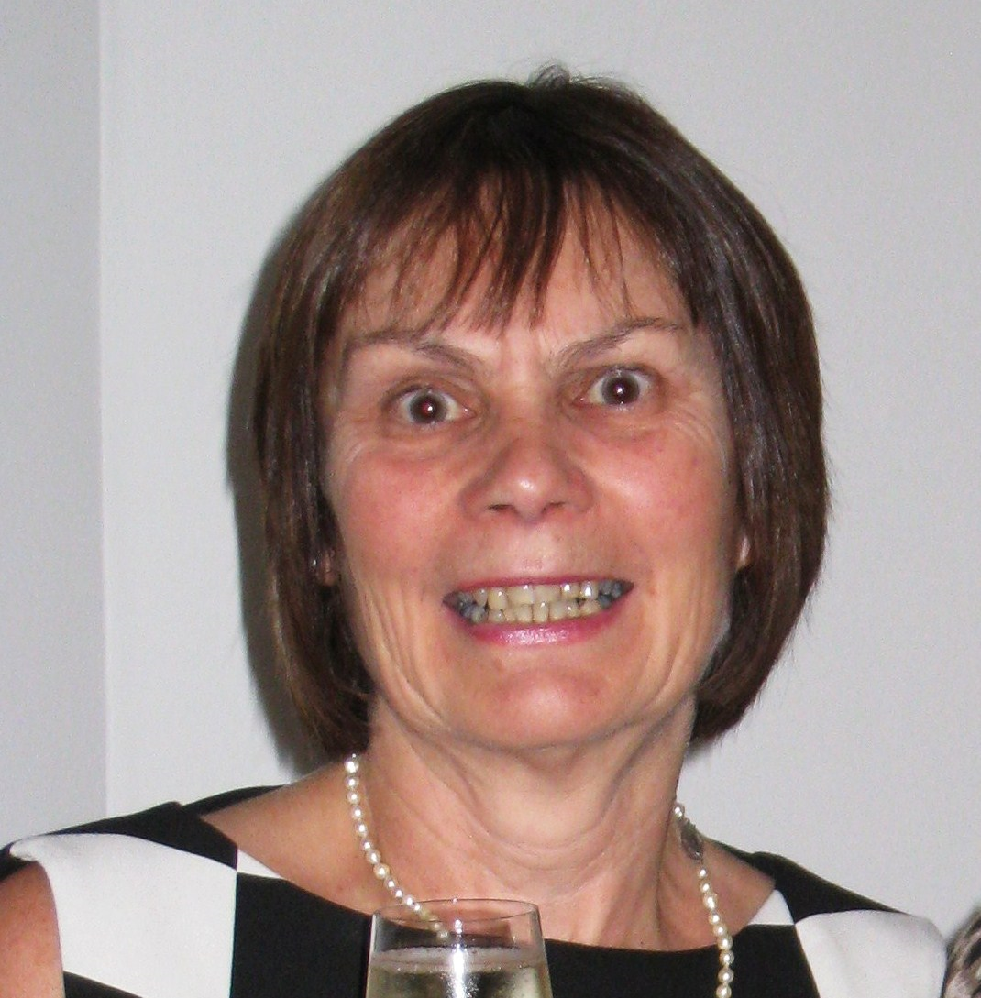

**ABOUT THE SPEAKER –** Alice Foster MA is a freelance art historian of more than 20 years’ experience and has been an accredited lecturer with The Arts Society since 2004. She has worked for Oxford University’s Department of Continuing Education, Oxford’s Ashmolean Museum and the Three Counties History of Art Society, amongst others. She has previously taken study tours in Europe, and in 2025 will take lecture tours in Australia and New Zealand.